Step 1: Log In
Log in to your Braintree account.

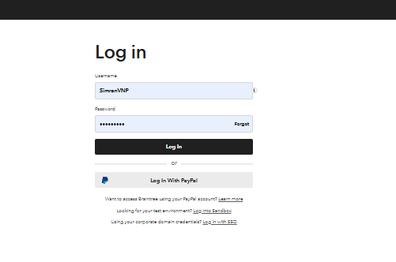

Step 2: Navigate to Transactions
Once logged in, select the “Transactions” tab from the main menu.
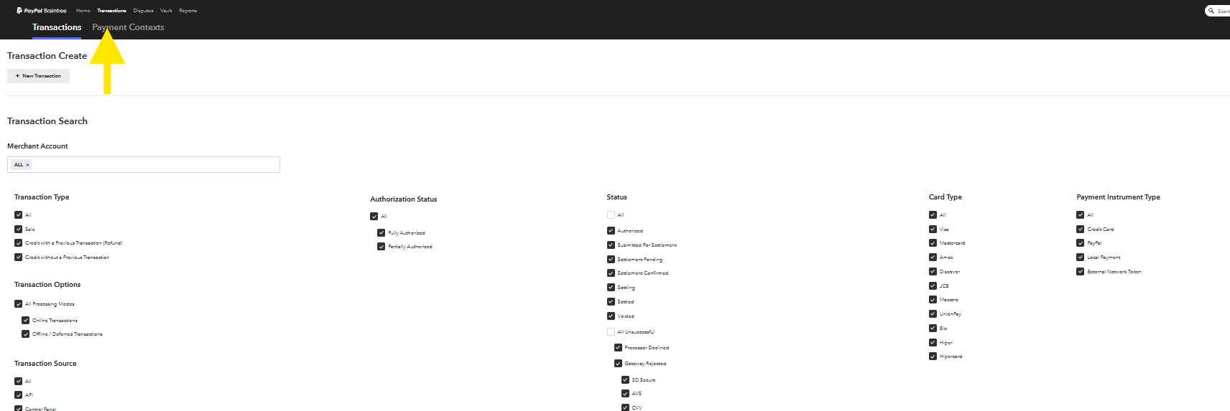

Step 3: Initiate a New Transaction
Click on “New Transaction.”
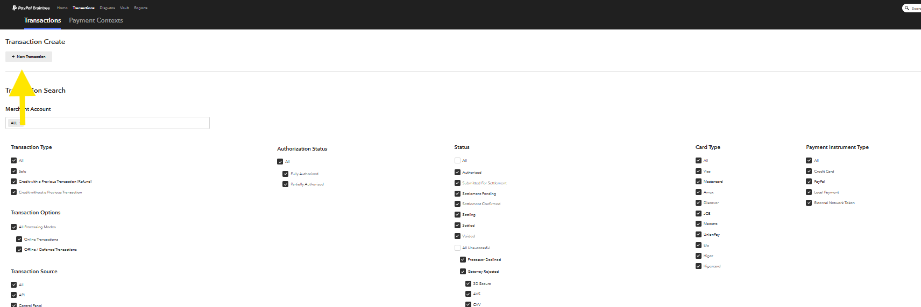

Step 4: Enter Transaction Information
- Merchant Name: Select the appropriate merchant based on the property name and currency.
- Amount: Enter the transaction amount.
- Order ID: Enter the reservation number.
- Leave all other fields unchanged.

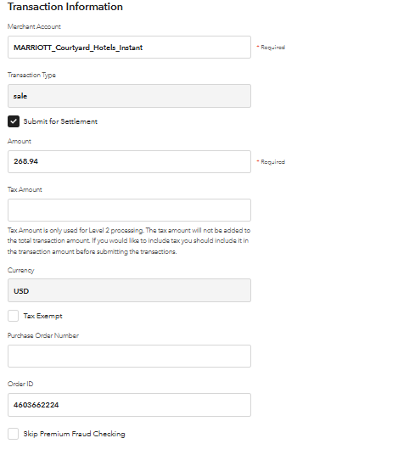

Step 5: Enter Customer Information
- Customer First Name: Enter the property name.
- Leave all other fields unchanged.

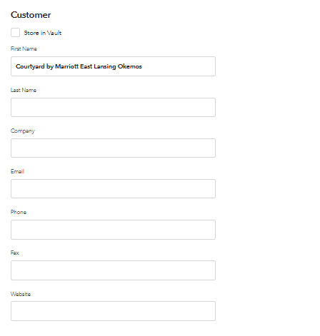

Enter Payment Information
- Cardholder Name: Enter the name based on the OTA:
  - Expedia: Expedia Group
  - Booking.com: Booking.com
  - Agoda: Agoda Ltd.
- Fill in the Credit Card Number, Expiration Date, and CVC Code in their respective fields.

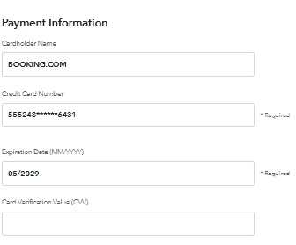

Enter Billing Address
Use the billing address associated with the respective OTA:
- Agoda
  - Zip Code: 80525
  - Customer: Agoda Company Pte Ltd.
  - Country Code: US
- Expedia
  - Zip Code: 98119
  - Customer: Expedia Group
  - Country Code: US
- Booking.com
  - Zip Code: 10118
  - Customer: Booking.com
  - Country Code: US

- Finalize the Transaction
- Click “Create Transaction” to process the payment.

